**203 Prep Lab**

**For this assignment, complete the following:**

**Part1: Setup GitHub:** Provide the screen shots of your GitHub account with Assignment 0 file is uploaded on GitHub

**Part 2 -Install JDK, Test java Application from Command Line**

Provide the screen shots from Step 1 and 2 here:

STEP 1:

**STEP 2:**



**Part 3 - Install Eclipse, Test Eclipse Java Application**

Provide the screen shots from Step 1 and 2 here:

STEP 1:

**STEP 2:**

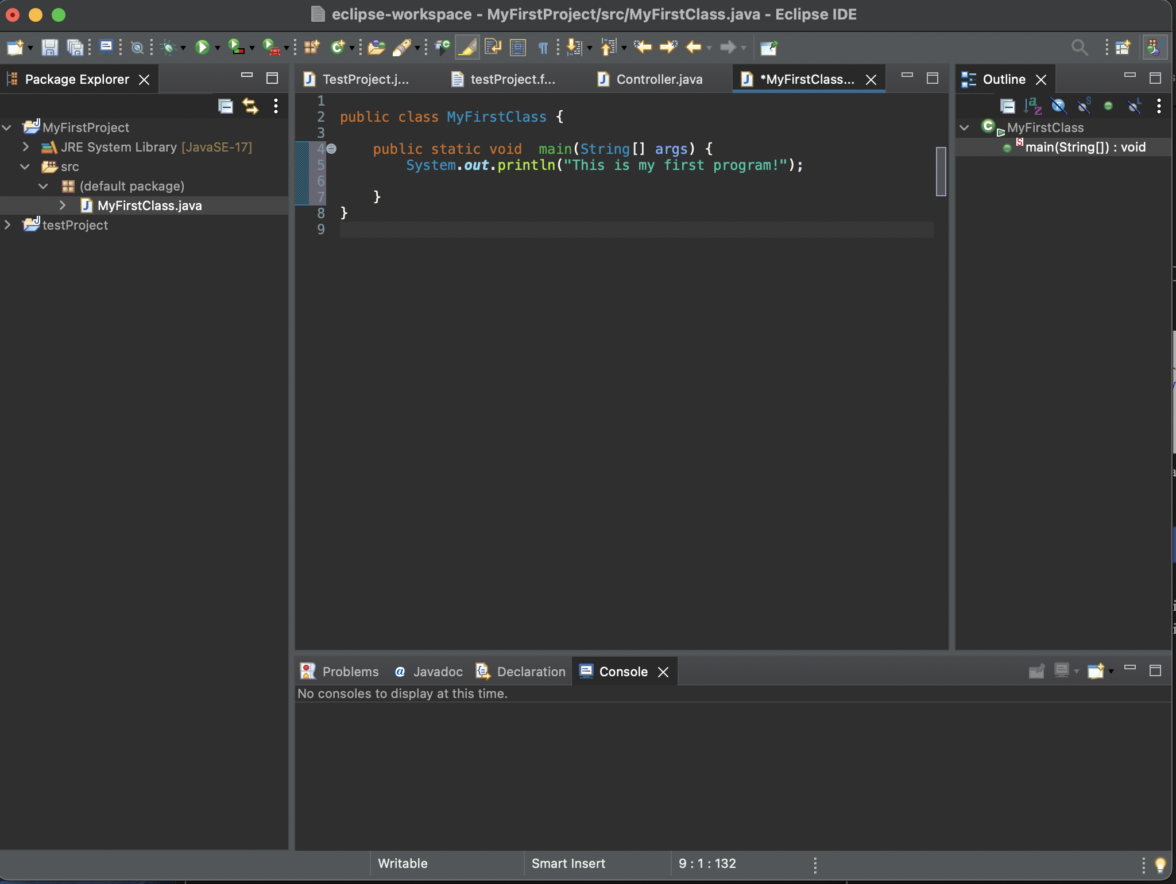

**Part 4 - Install, Setup, Test Junit Program.**

Provide the screen shots showing:

* 1. Eclipse with working JUnit Test example

* 1. Project screenshot

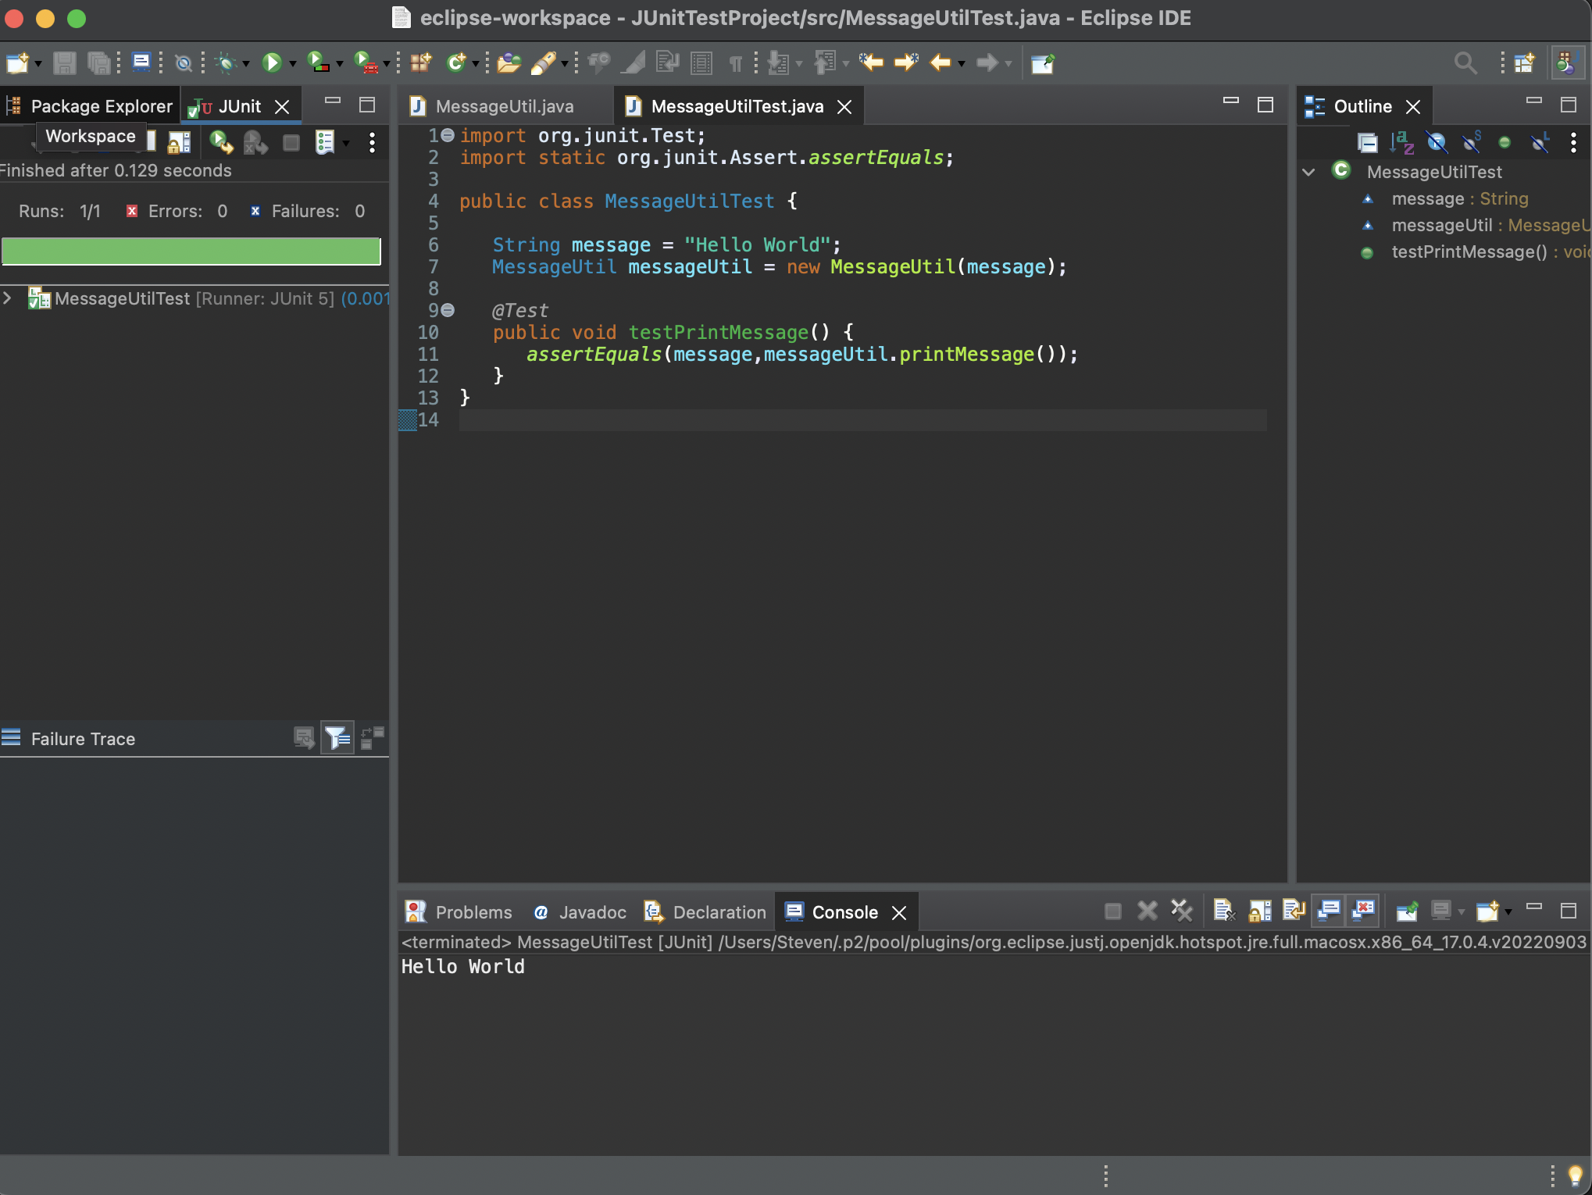

* 1. Running example screenshot

**Part 5 - Install, Setup, and Test JavaFX Application.**

Provide the screen shots showing:

1. JavaFX Project screenshot

1. Running example screenshot

In a write-up, capture the following: (See sample submission)

Class: CMSC203 CRN 22377

 Program: 203 Prep Lab

Instructor: Gary Thai.

 Due Date: 09/16/2022

 Integrity Pledge: I pledge that I have completed the programming assignment independently.

 I have not copied the code from a student or any source.

**Lessons Learned** <Provide answers to the questions listed below>**:**

Write about your Learning Experience, highlighting your lessons learned and learning experience from working on this assignment.

What have you learned?

Learning about JavaFX and various other programs that I had to install.

What did you struggle with?

I struggled with a lot of the installation process because the instructions being based for windows and I am working on a mac.

What parts of this assignment were you successful with, and what parts (if any) were you not successful with?

I was successful with all the parts of the assignment thankfully and got everything up and running.

Provide any additional resources/links/videos you used to while working on this assignment.

**Check List:** <Provide answers to the column Y/N or N/A >**:**

|  |  |  |  |
| --- | --- | --- | --- |
| **#** |  | **Y/N** | **Comments** |
|  | **Assignment files:** |  |  |
|  | * FirstInitialLastName_Assignment0.docx/pdf | **yes** |  |
|  | * Source java files |  |  |
|  | **Program compiles** |  |  |
|  | **Program runs with desired outputs related to a Test Plan** |  |  |
|  | **Documentation file: Screenshots of** |  |  |
|  | * Part1: Setup GitHub | **yes** |  |
|  | * Part 2 -Install JDK, Test java Application from Command Line | **yes** |  |
|  | * Part 3 - Install Eclipse, Test Eclipse Java Application | **yes** |  |
|  | * Part 4 - Install, Setup, Test Junit Program | **yes** |  |
|  | * Part 5 - Install, Setup, and Test JavaFX Application. | **yes** |  |
|  | * Lessons Learned | **yes** |  |
|  | * Checklist is completed and included in the Documentation | **yes** |  |